ECE 3355 – ELECTRONICS
HOMEWORK #9

Sedra and Smith 8th Ed. Chapter 6: Problems 6.28, 6.29, 6.66, 6.67
Problems E9.1, E9.2 (see below)

E9.1: Find the dc bias values for these transistors. In other words, find V_{B}, V_{C}, V_{E}, I_{B}, I_{C}, and I_{E}. Assume β = 300.
- 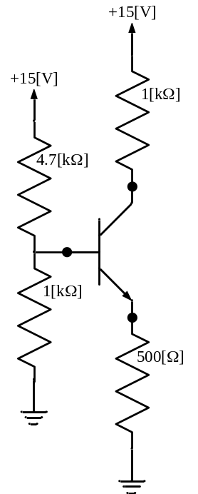 b) 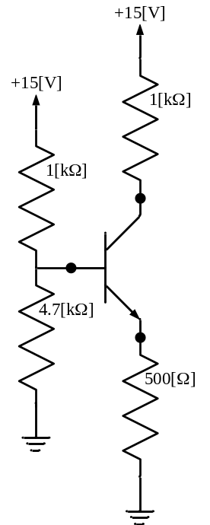
c) 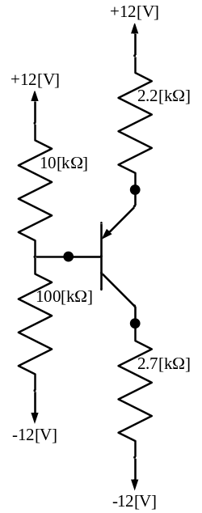 d) 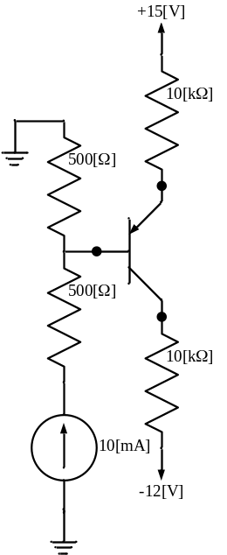
E9.2: Frind the dc bias values for these transistors. In other words, find V_{B}, V_{C}, V_{E}, I_{B}, I_{C}, and I_{E}. Assume β = 150. Assume that the diodes can be modeled with a piecewise linear diode model with I_{s} = 0, V_{f} = 0.7[V], and r_{d} = 0.
- 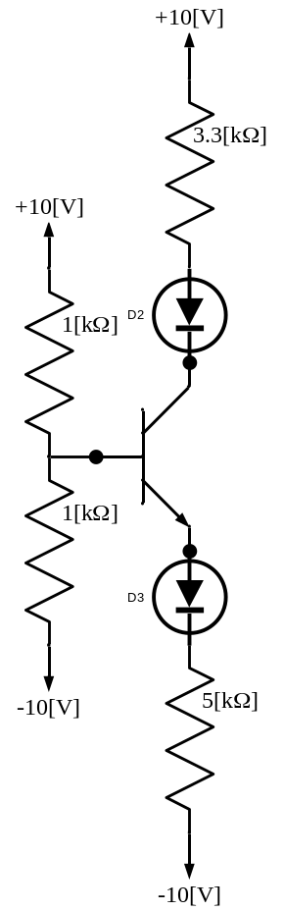 b) 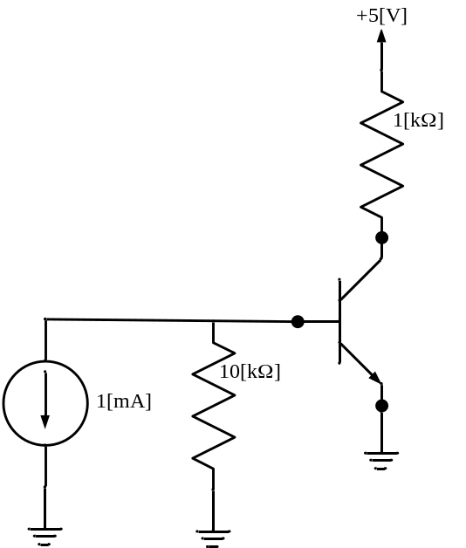
c) 